**CP Club 365 Days Challenge**

**Programming language – C++**

**Problem Statement**

https://www.codechef.com/problems/FRUITS

Git :- <https://github.com/Vedantbharad2603/CP_club_365_Days>

**Your Code**:

// 0x102Day of 0x365Days challenge

// VEDANT BHARAD

// 27-1-2023

#include <bits/stdc++.h>

using namespace std;

int main(){

    int t;

    cin>>t;

    while(t--){

        int n,m,k;

        cin>>n>>m>>k;

        int diff=abs(n-m);

        if(diff<=k)

            cout<<"0"<<endl;

        else

            cout<<diff-k<<endl;

    }

}

**Output (Screen Shot)**:

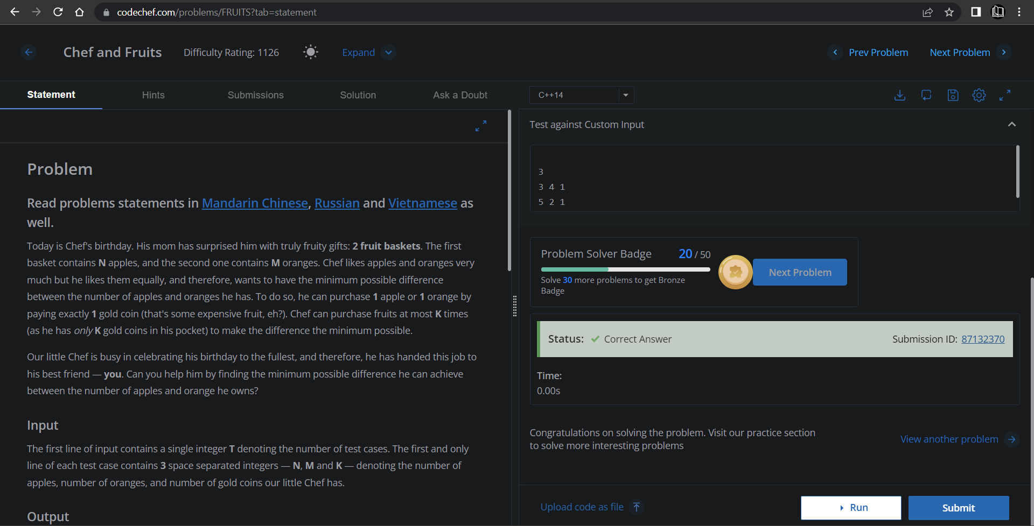

**Understanding about problem:**

* In this task I need to make “n” and “m” nearly same so that the difference will be less and to make that I have k value to add where I need and at last return difference.

Note: If you can't understand the problem, feel free to contact us and we'll help you. Please don't copy and paste from anywhere.

ALL THE BEST

Team CP Club